**Process Definition Document**

|  |  |
| --- | --- |
|  |  |

Extract Corona Numbers

Date: 09-09-2025

**Process Design Document History**

|  |  |  |  |  |  |  |  |
| --- | --- | --- | --- | --- | --- | --- | --- |
| Date | Version | Role | Name | Organization | Function | Comments | |
| 09.09.2025 | **1.0** | **Author** | **Amr Ayman** | **Raya IT** | **BA, RPA Developer** | | **Creation v1.0** |
|  |  |  |  |  |  | |  |

# Table of Contents

Process Definition Document 0

0

Table of Contents 1

I. Introduction 2

I.1 Purpose of the document 2

I.2 Objectives 2

I.3 Process key contact 3

II. As-Is process description 4

II.1 Process Overview 4

II.2 Standard of Metrics 4

II.3 Applications used in the process 5

II.4 Business Rules 5

II.5 As-Is Process map 6

II.6 Detailed As-Is Process Steps 8

II.7 Exceptions Handling 11

III. To-Be Process Description 12

III.3 In Scope of RPA 12

III.4 Out of Scope of RPA 12

IV. Other Observations 13

IV.1 Systems 13

IV.2 Reporting 13

# Introduction

## I.1 Purpose of the document

The Process Definition Document outlines the business process chosen for automation using UiPath Robotic Process Automation (RPA) technology.

The document describes the sequence of actions performed as part of the business process, the conditions and rules of the process prior to automation and how they are envisioned to work after automating it, partly or entirely. This specifications document serves as a base for developers, providing them with the details required for applying robotic process automation to the selected business process.

## I.2 Objectives

The Automation of the full process of extracting corona numbers of different countries based on user choice, reducing the Human interaction to approximately none, the system will operate seamlessly throughout the edge browser and notepad desktop app delivering faster processing , reducing the duration time of time-consuming activities and improving departments’ overall performance and reliability.

|  |  |
| --- | --- |
| Objectives | Expected Benefits |
| Automate almost the full Process Extract Corona Numbers | **Decrease manual intervention to almost zero, ensuring end-to-end seamless execution using user input only at the beginning.** |
| Reduce human interaction to almost zero | **Minimize errors from manual handling, improve compliance and accuracy** |
| Accelerate processing speed of verification tasks | **Shorten overall task cycle time, enabling faster turnaround for stakeholders** |
| Reduce duration of time-consuming activities | **Free up staff capacity for higher-value activities, leading to productivity gains** |
| Improve overall department performance | **Standardized processes, ensuring consistency and scalability** |
| Increasing system reliability through automation | **Lower risk of process failure, improve trust in system outputs** |
| Support continuous operations with minimal downtime | **Enhance operational efficiency and customer satisfaction** |

## I.3 Process key contact

|  |  |  |  |
| --- | --- | --- | --- |
| ****Role**** | ****Name**** | ****Contact details (email, phone number)**** | ****Notes**** |
| **Business Analyst, RPA Developer** | **Amr Ayman - Raya IT** | **amr@gmail.com** |  |
| **SME** | **Eng. Mohamed Mesbah** | **M.Mesbah@gmail.com** | **Contact for questions, details, approvals** |

# As-Is process description

## II.1 Process Overview

The Extraction of Corona Numbers is currently performed manually across Edge Browser and Notepad apps, Employee must open the edge browser and go to the corona world ometer website and extract the data in it then store it in txt file.

The process involves repetitive steps such as Extracting pdf data and documenting missing data to add.

Due to the high level of manual intervention, the task is time-consuming, error-prone, and dependent on staff availability, often leading to delays in verification, inconsistent outputs, and operational inefficiencies. Additionally, manual handling increases the risk of overlooking discrepancies, requiring additional rework and cross-departmental follow-ups.

## II.2 Standard of Metrics

|  |  |  |
| --- | --- | --- |
| **#** | **Item** | **Description** |
| **1** | **Process full name** | **Extract Corona Numbers** |
| **2** | **Process Area** | **Mobilization and Statistics** |
| **3** | **Department** | **Mobilization and Statistics** |
| **4** | **Process short description (operation, activity, outcome)** | **Open edge and search for country worldometer , choose the first link and extract the data (cases, deathes, recovery) and save them to txt file** |
| **5** | **Process schedule and frequency** | **Everyday 2 times, 1 at 8:00 am , 1 at 8:00 pm** |
| **6** | **# of items process / month** | **~60** |
| **8** | **Process execution time** | **2 mins** |
| **9** | **Peak period (s)** | **NA** |
| **10** | **Transaction Volume During Peak period** | **NA** |
| **11** | **Total # of FTEs supporting this activity** | **4** |
| **13** | **Level of exception rate** | **10%** |
| **13** | **Input data** | **Country Name** |
| **14** | **Output data** | **Txt file contains country corona data** |
| **15** | **Return on Investment** | **Reduce the processing time by 80% and FTE to almost zero** |

## II.3 Applications used in the process­

|  |  |  |  |  |  |
| --- | --- | --- | --- | --- | --- |
| # | Application name & version | System Language | Thin/Thick Client | Environment/ Access method | Comments |
| **1** | **Edge Browser** | **English** | **Thick** | **Desktop App** | **Majority of processing** |
| **2** | **Note Pad** | **English** | **Thin** | **Desktop App** | **Used only for saving data** |

## II.4 Business Rules

|  |  |
| --- | --- |
| Business Rule | Description |
| BR-01 | **The input country must be valid country name** |
| BR-02 | **The user must use edge browser** |
| BR-03 | **The user must open the first link to appear** |
| BR-04 | **The user must get corona deaths, cases, recoveries data only** |
| BR-05 | **The user must edit the font of data in txt file as ; Fixedsys, Bold, 28** |
| BR-06 | **The user must save the txt file as “{country name}-{Datetime created}.txt”** |
| BR-07 | **The user must save the file in the folder “Corona Numbers”** |

## II.5 As-Is Process map

### High Level As-Is Process Map:

This chapter depicts the As-Is business process at a High Level to enable developers to have a high-level understanding of the current process.

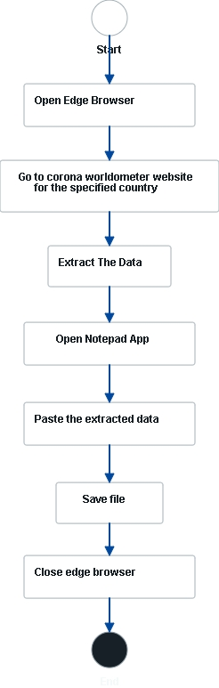

### Detailed As-Is Process Map:

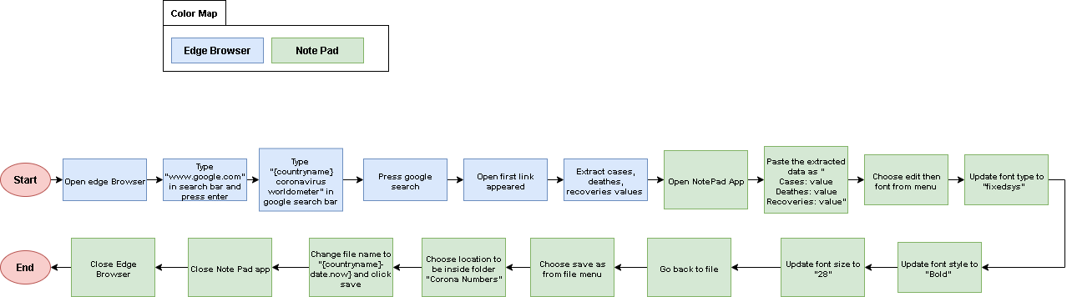

|  |  |
| --- | --- |
| Step | Short Description |
| 1.1 | **Open edge browser** |
| 1.2 | **Type "www.google.com" in search bar and press enter** |
| 1.3 | **Type "{country name} coronavirus world ometer" in google search bar** |
| 1.4 | **Press google search** |
| 1.5 | **Open first link appeared** |
| 1.6 | **Extract cases, deaths, and recoveries values** |
| 1.7 | **Open Note Pad App** |
| 1.8 | **Paste the extracted data as "Cases: value Deaths: value Recoveries: value"** |
| 1.9 | **Choose edit then font from menu** |
| 1.10 | **Update font type to "Fixedsys"** |
| 1.11 | **Update font style to "Bold"** |
| 1.12 | **Update font size to "28"** |
| 1.13 | **Go back to file** |
| 1.14 | **Choose save as from file menu** |
| 1.15 | **Choose location to be inside folder "Corona Numbers"** |
| 1.16 | **Change file name to "{country name}-{current date}” and click save** |
| 1.17 | **Close Note Pad app** |
| 1.18 | **Close Edge Browser** |

## II.6 Detailed As-Is Process Steps

|  |  |  |  |  |
| --- | --- | --- | --- | --- |
| Step | Step Action Description | Screen Shot | Expected Result | Possible Exception |
| 1.1 | **Open edge browser** |  |  | SE-01 |
| 1.2 | **Type "www.google.com" in search bar and press enter** |  |  |  |
| 1.3 | **Type "{country name} coronavirus world ometer" in google search bar** |  |  | BE-01 |
| 1.4 | **Press google search** |  |  |  |
| 1.5 | **Open first link appeared** |  |  | BE-02 |
| 1.6 | **Extract cases, deaths, and recoveries values** |  |  | BE-03 |
| 1.7 | **Open Note Pad App** |  |  | SE-01 |
| 1.8 | **Paste the extracted data as "Cases: value Deaths: value Recoveries: value"** |  |  |  |
| 1.9 | **Choose edit then font from menu** |  |  |  |
| 1.10 | **Update font type to "Fixedsys"** |  |  |  |
| 1.11 | **Update font style to "Bold"** |  |  |  |
| 1.12 | **Update font size to "28"** |  |  |  |
| 1.13 | **Go back to file** |  |  | BE-04 |
| 1.14 | **Choose save as from file menu** |  |  |  |
| 1.15 | **Choose location to be inside folder "Corona Numbers"** |  |  |  |
| 1.16 | **Change file name to "{country name}-{current date}” and click save** |  |  | BE-05 |
| 1.17 | **Close Note Pad app** |  |  |  |
| 1.18 | **Close Edge Browser** |  | **Edge closed** |  |

## II.7 Exceptions Handling

|  |  |  |
| --- | --- | --- |
| # | Exception | Expected Action |
| SE-01 | **Something went wrong when open application** | **Try again 1 time , if not log message “failed to open edge browser”** |
| BE-01 | **Wrong country name added in search** | **Log message “please check the country name”** |
| BE-02 | **The desired web page not appearing as first link** | **Try the second appearing link , the third till the end of page** |
| BE-03 | **Corrupted data when extracting** | **Refresh the page till 3 times, then log message “data is corrupted”** |
| BE-04 | **Not Applying font edits** | **Select all text and then apply manually** |
| BE-05 | **When saving file, there is file with same name in folder** | **Choose to replace it with the new one** |

# To-Be Process Description

## III.1 To – Be Process map

## III.3 In Scope of RPA

The activities in of the scope of RPA:

All Process is inside scope of RPA except the user input of country

## III.3 Out of Scope of RPA

User Input of country to search with

# Other Observations

## IV.1 Systems

|  |  |  |
| --- | --- | --- |
| System | Usage | Frequency |
| Edge Browser | **Primary use for process** | **Once / case** |
| Note Pad | **Used to save the extracted data** | **Once / case** |

## IV.2 Reporting

|  |  |  |
| --- | --- | --- |
| Report Name | Source | Purpose |
| Txt file with extracted data | **Automated System** | **Save the extracted data** |